Quantitative Image Analysis-Driven Computational Framework Reveals Depth-Dependent Biomechanical Impact of Collagen Degradation in Articular Cartilage
Saiful Islam¹, Asif Istiak¹, Imrul Kayes¹, Tanvir Faisal¹
¹University of Louisiana at Lafayette, Lafayette, LA
Email of Presenting Author

Disclosures:

INTRODUCTION: Progressive collagen network degradation represents a critical pathomechanical feature of osteoarthritis (OA), disrupting cartilage load-bearing capacity and altering the mechanical microenvironment of chondrocytes. Despite its importance, the spatial heterogeneity of collagen degradation and its zone-specific biomechanical consequences are not fully characterized. This study combines quantitative image analysis (IA) with computational biomechanics to map enzymatic collagen degradation patterns and predict their impact on cartilage tissue mechanics and chondrocyte deformation behavior.

METHODS: Cartilage explants underwent enzymatic digestion using matrix metalloproteinases (MMPs) and a disintegrin and metalloproteinase with thrombospondin motifs (ADAMTS) to simulate pathological degradation. Samples were processed through Picrosirius Red staining, paraffin embedding, and sectioned at 5 µm thickness. Collagen content was quantified via IA based on red intensity under standard light microscopy, with validation by Fourier Transform Infrared (FTIR) spectroscopy [1]. An axisymmetric FE model was developed incorporating key extracellular matrix (ECM) constituents—type II and VI collagen fibrils, proteoglycans (PGs), pericellular matrix (PCM), and chondrocytes—and validated against healthy cartilage properties. IA-derived degradation values (25% superficial zone (SZ), 22% middle zone (MZ), 16% deep zone (DZ)) were implemented to simulate graded collagen loss and investigate resulting chondrocyte mechanobiological responses.

RESULTS SECTION: Quantitative IA successfully captured depth dependent collagen degradation following enzymatic treatment, revealing significantly higher degradation in SZ (24.62 ± 14.42%) compared to MZ (21.94 ± 6.38%) and DZ (15.80 ± 10.51%). FE simulations incorporating these experimentally derived degradation profiles demonstrated depth-dependent alterations in tissue deformation patterns and chondrocyte morphological responses. Specifically, collagen degradation induced chondrocyte aspect ratio changes of 6.35%, 5.99%, and 3.77% in SZ, MZ, and DZ, respectively, establishing a quantitative relationship between matrix degradation severity and cellular mechanical strain.

DISCUSSION: This study successfully integrated quantitative IA with FE modeling to link zone-dependent collagen degradation with cartilage biomechanics. The observed degradation gradient, highest in superficial regions and decreasing with depth, demonstrates early OA pathology. Computational simulations revealed that collagen degradation elevates mechanical strain across all tissue components (ECM, PCM, and chondrocytes), with superficial chondrocytes experiencing the most pronounced morphological alterations. This demonstrates that collagen network integrity is critical for maintaining physiological load distribution and protecting cells from excessive mechanical strain. Limitations include isolated collagen degradation without concurrent proteoglycan loss that occurs in actual OA, and lack of experimental validation of predicted cellular deformations. This IA-FE framework provides mechanistic insights into OA progression and identifies potential therapeutic targets for structure-modifying interventions.

SIGNIFICANCE/CLINICAL RELEVANCE: This integrated experimental-computational approach addresses a critical knowledge gap in understanding how early-stage matrix degradation drives chondrocyte mechanical dysfunction in OA pathogenesis. By establishing quantitative relationships between tissue composition and cellular mechanics, this framework enables prediction of disease progression patterns and identification of biomechanical intervention targets, potentially guiding development of structure-modifying therapies and early diagnostic strategies.

REFERENCES: 1. Rahunen, K., et al. (2016). "Evaluation of quantitativity of histological collagen stains in articular cartilage." Osteoarthritis and Cartilage 24: S307-S308

IMAGES AND TABLES:
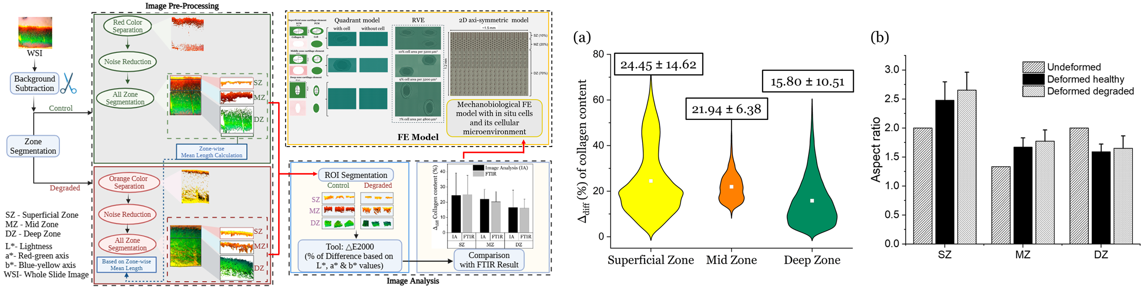

Fig 1: Workflow of collagen quantification and FE model Fig 2: Difference between healthy and degraded cartilage (a) (%) in
collagen content (b) chondrocyte aspect ratio.

